**YEAR 6 NEW INTAKE PARENTS’ MEETING**

**INFORMATION BOOKLET**

**2018/2019**

**CONTENTS**

|  |  |
| --- | --- |
|  | **Page** |
| Welcome – Introduction by Headteacher | 3 |
| Mission Statement /The Spirit of our School | 4 - 5 |
| Your first day /The school day | 5 - 7 |
| Lunchtime Procedures | 7 - 8 |
| Homework/Pupil Planners/Reporting to Parents | 8 - 9 |
| School House System | 9 - 10 |
| General Information – Property/Lockers/Illness | 10 - 11 |
| Holidays 2017/2018 | 12 - 13 |
| School Uniform | 14 - 18 |
| Order & Discipline/Rationale Underpinning the School Behaviour Policy | 19 - 20 |
| Code of Conduct | 21 |
| Attendance | 22 - 24 |
| Transport/Bus timetables | 25 - 27 |
| Cashless Catering System/Wisepay  Free School Meals/Pupil Premium  Laptops for Pupils  Images/Photographs/Publications  Privacy Notice  Donations/Technology/Building Levy  Fundraising and Marketing | 28 - 30  31  32  33  34 - 40  41 – 42  43 |
| **Appendices**  New Intake Parents’ Evening Evaluation |  |
| Pupil Detail Form |  |
| Combined Parental Consent Form  EBIU Form  Bus Code of Conduct |  |
| **Please use the envelope provided to return all the appropriate forms preferably on Y6 INTRODUCTION DAY (5TH JULY) BUT NO LATER THAN Monday 9th July 2018.** |  |
|  |  |
|  |  |
|  |  |
|  |  |
|  |  |
|  |  |

**WELCOME**

I would like to extend a very warm welcome from everyone at St Edmund Arrowsmith Catholic High School to all new pupils and parents, welcome to our family! I know exactly how your sons and daughters are feeling, as I was in exactly the same situation a number of years ago moving from a Catholic Primary School to a Catholic Secondary School in Wigan. I also know the next five years are incredibly important in shaping the type of young adult your son or daughter develops into.

We take this responsibility incredibly seriously and we understand they will only get one chance at Secondary School, we are all determined to make their time here productive, inspiring, engaging and most of all, happy.

I hope you find the information in this pack useful and that it answers your questions. If there is anything at all you are unsure about please do not leave without asking a member of staff.

Everyone is made to feel welcome at St Edmund Arrowsmith Catholic High School and we value our tremendous relationships with our parent body, and as such, I would recommend that if you ever have any concerns, queries or questions please arrange to meet the appropriate staff member, you will be sure to find a warm and courteous welcome.

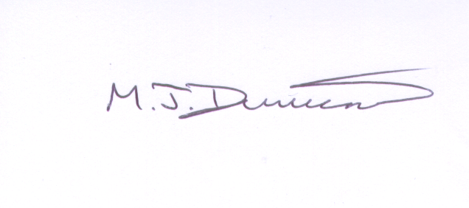

M.J. DUMICAN

HEADTEACHER



**THE SPIRIT OF OUR SCHOOL**

St Edmund Arrowsmith is a Catholic school. The traditions and teachings of the Catholic Faith are adhered to and promoted. The first responsibility for the teaching of the Faith lies with parents; however, we are happy to be partners in this process. In order to facilitate and nurture faith, the School undertakes to provide:

1. Prayers, morning and evening.
2. Grace before and after meals.
3. Regular voluntary Masses.
4. Year Masses and Whole School Masses on Holy Days of Obligation.
5. Lenten and Advent Prayer.
6. Various liturgies during the year.
7. Participation in Charitable works and fundraising.
8. Away Days, Retreats and Pilgrimages.

At St Edmund Arrowsmith we employ a full time School Chaplain. The role of the Chaplain is to have a presence in school and help to develop and deepen Spirituality amongst staff and pupils. The Chaplain provides resources for collective worship including assemblies and arranges opportunities for daily prayer. The Chaplain aims to enhance a Christian environment where everyone is able to feel loved and welcomed, is given a sense of dignity and respect and comes to know that they are made in the image and likeness of God.

The Chaplain is there to give time to both staff and pupils whenever it is sought – an ear to listen, a comforting word. The Chapel provides a quiet space for private prayer or to gather thoughts. We appreciate the support parents give to the children in all aspects of their life. We will seek to enable parents to foster the spiritual development of their children.

The work of a Chaplain cannot be easily explained in a few sentences. However, the Chaplain is doing their best work when they are ‘just amongst’ the pupils and staff and giving of themself.

We expect all members of our community to respect the beliefs and practices of the Catholic Church.

We ask for your support in encouraging your child to take an active part in the prayer and worship of our school community and their local parish community.

Please do not hesitate to contact us if you have any questions or suggestions regarding the spiritual aspects of school life.

**YOUR FIRST DAY**

Your first day at St Edmund Arrowsmith Catholic High School, Tuesday 04 September 2018, will start at 8.35am, when you will attend a special Assembly to welcome you to the school. Pupils are asked to assemble on the playground adjacent to the Gym windows before the Assembly.

After Assembly you will be taken by your Form Tutor to your Form Room, where you will be given all the information you need to know about your new school. You will also be issued with your Pupil Planner and you will be given time to copy out your timetable. Do not forget to keep the Pupil Planner safe and carry it with you at all times.

After Period 1 you will then start your lessons. Each subject teacher will issue you with an exercise book. Look after your books carefully.

**Tuesday 04 September 2018**

8.35am Arrive at School - Y7 Pupils assemble on playground

8.40 – 9.00am Assembly in Main Hall for Pupils

9.00 – 9.55am Form Period

9.55 – 10.55am Period 2

10.55 – 11.10am Break

11.10am – 12.10pm Period 3

12.10 – 12.45pm Period 4

12.45 – 2.00pm Lunch

2.00 – 2.05pm Movement Time

2.05 – 3.05pm Period 5

On **Friday 28 September 2018**, Year 7 pupils will be taken to St Oswald’s Church where Holy Mass will be offered for their happiness and success in their new school. Parents are invited to attend this Mass. Mass starts at 12.15pm

**KEY STAFF**

Your child will be taught by many different teachers during his/her time at St Edmund Arrowsmith Catholic High School. However, in his/her first year the following teachers will play a key role.

Senior Learning Coordinator: Mrs R Outterside

Assistant Learning Coordinator: Mrs L Alvarado

Form Tutors:

7A Mr M Kennedy

7B Miss R Whittle

7C Miss C Brophy

7G Mr J Tickle

7H Mrs R Woods/Ms C Kelly

7L Mrs A Davies

7M Mrs A Bailey

7O Mrs J Melling

7S Mrs C McGoldrick

7W Mr J Bateman/Mrs S McDonnell

**BASIC EQUIPMENT**

Pupils should arrive at school equipped for learning. Pupils will need a suitable bag, a pen, pencil, ruler and an eraser for all lessons. Year 7 pupils will be expected to bring a pencil case each day, which will be monitored as part of Pastoral procedures.

Specialist subjects e.g. PE and Technology etc. may require additional items of which pupils will be informed. All items of equipment, including clothing, should be suitably labelled.

Pupils need to be organised and ready for the school day and should not arrive at any lesson without being properly equipped for that lesson.

**THE SCHOOL DAY**

**Morning Arrangements**

Pupils are expected to be in school by 8.35am. There is general supervision of the site by senior staff from 8.00am and pupils are able to utilise the Dining Room facilities from 8.00am onwards. The school library is available for pupils from 8.00am, during break and lunchtime and after school until 4pm (Tuesday-Friday only)

We ask parents to arrange for pupils to arrive at school as near to 8.30am as possible, and no later than 8.35am.

**Assemblies**

At 8.35am the bell indicates that pupils should go to assembly or registration; these begin at 8.40am.

The assemblies are normally:

MONDAY Year 7

TUESDAY Year 8

WEDNESDAY Year 9

THURSDAY Year 10

FRIDAY Year 11

**Lessons**

At the 8.55 am bell, pupils will proceed to lessons. The school day consists of five lessons, each of 1 hour duration.

8.40am - 8.55am Registration

8.55am - 9.55am Period 1

9.55am - 10.55am Period 2

10.55am - 11.10am BREAK

11.10am - 12.10pm Period 3

12.10pm - 1.10pm Period 4

1.10pm - 2.00pm LUNCH

2.00pm - 2.05pm Movement Time

2.05pm - 3.05pm Period 5

**LUNCHTIME PROCEDURES**

**Dinner Break**

There are two alternatives open to pupils for the lunch hour: -

1. The purchase of a school meal from the Main Dining Room or the Unit Dining Room.

2. A packed lunch brought from home and eaten in the Main Hall.

Pupils are not allowed to leave the premises to purchase food items outside.

Any pupils wishing to have dinner at home must provide a written request from a parent or guardian. Letters are to be taken to Mrs Morgan at morning registration.

There are two Dining Rooms - the main one near the school entrance and the smaller Unit Dining Room.

All pupils eating sandwiches dine in the Main Hall.

Our “cashless” catering system requires the pupils to be biometrically registered. They can then load cash onto the revaluation units situated in the Dining Room or bring in a cheque made payable to Catering Academy Ltd with their name and form on the reverse. All transactions at the point of service are then automatic and so queuing times are reduced. Parents who do not wish their child to be biometrically registered may request a Smartcard as an alternative. Those pupils entitled to a free school meal are automatically credited with the prescribed amount on a daily basis. Payments can also be loaded online by accessing Wisepay through the Parent Portal.

**HOMEWORK**

All pupils are expected to do homework and are given homework guidelines at the beginning of each year. Experience teaches us that good academic standards are not achieved unless homework is done regularly and systematically. Parental support is essential to enable a child to develop a regular homework routine.

The aim is to give pupils about an hour’s work each evening in Year 7, about one and a half hour’s work in Years 8 and 9; in Years 10 and 11, the amount of homework is dictated by the examination courses being followed but should rarely be less than an average of two hours per evening. Pupils record their homework in their Pupil Planner. They must be encouraged to work at home, observing the evening’s homework period conscientiously, preferably in a quiet room on their own. If a pupil appears to have too much or too little homework, the Senior Learning Coordinator should be contacted.

**PUPIL PLANNERS**

All pupils in Year 7 - 11 have a Pupil Planner and must use it at all times.

It is used for:

1. A homework record.
2. Sending messages home such as subject comment - good or bad - on work or behaviour.
3. Messages to school from parents - explanation of lateness or absence.
4. Recording achievements out of school.
5. Monitoring attendance and punctuality.

The Pupil Planners are checked each week by the Form Tutor and parents are asked to sign it each week when they have checked their son/daughter’s homework. The Pupil Planner also contains a section relating to the School’s Internet Policy. For pupils to access the internet in school, parents must read the conditions set and sign the permission slip which is included.

**REPORTING TO PARENTS**

All pupils leaving St. Edmund Arrowsmith High School receive a Record of Achievement Folder. This recognises and records pupils’ achievements in and outside school, giving credit for curricular and extra-curricular achievement.

All pupils will participate in a Review Day in July. This involves parents meeting with their child's Form Tutor or Co-Tutor to discuss progress and set targets. Pupils are not in school on the Review Day, but accompany their parents to the scheduled meeting.

Each Year Group has a Parents’ Consultation Evening during the school year. In addition, parents are invited to attend a Guidance Evening which is aimed at keeping parents informed of, and involved with, their child's learning. A calendar of important dates is available to view on our website and is regularly updated.

**THE SCHOOL HOUSE SYSTEM**

A House System is operated within the school and is considered to be valuable because it:

1. Gives a vertical structure to the school allowing pupils to meet, mix and co-operate with older or younger pupils outside their form or year;
2. Gives pupils an additional sense of belonging;
3. Allows pupils to meet staff they would not otherwise meet in their academic or form activities;
4. Encourages many pupils to take an active part in school life.

The saints, all English Martyrs, are: -

St John Almond St Robert Lawrence

St Ambrose Barlow St Cuthbert Mayne

St Margaret Clitherow St Nicholas Owen

St Edmund Gennings St Robert Southwell

St Philip Howard St Margaret Ward

Other year groups operate under a different system of houses. There will be a transition period but eventually all year groups will have ten tutor groups belonging to ten houses.

Pupils are placed in houses on entry to the school in September, and normally remain in the same house group until they leave school. House meetings are held termly under the guidance of Housemasters and Housemistresses.

An Achievement point competition runs throughout the year. Achievement points are collected on a weekly basis. Pupils can receive Gold, Silver and Bronze badges when a certain amount of Achievement points has been collected. Pupils may be awarded Achievement points for good work, extra effort, improvement or similar achievement and these marks are recorded against the individual pupil and for his or her House. Staff award Achievement points and record these directly onto the pupils profile on the Sims System. Parents can access this via the parent portal. The House with the highest total of marks is awarded the Competition Trophy, which it holds for twelve months. Pupils who receive a credible amount of Achievement points relative to their year group will be entered into a raffle to receive book vouchers at the end of the year. This will be awarded at the rewards assembly.

At various times during the year, other competitive events are held including Cross Country, Basketball, Netball, Soccer, Rugby, Rounders, Gymnastics, Cricket, Library Quiz, Inter-house Chess Competition.

The House with the best overall sports’ achievements is awarded the Sports Trophy. The school year culminates in Sports Day, when the ten houses compete for the Athletics Shield. Parents are welcome to attend. The House System provides the opportunity for healthy competition and it is hoped that all pupils enter whole-heartedly into the spirit of the House System and achieve a fuller school life.

**GENERAL INFORMATION**

**Personal Property**

Each pupil is responsible for her/his own property and each item should be **clearly marked or labelled with the pupil’s name.** Although the school keeps a close watch on property and lockers are provided, it cannot accept responsibility for losses.

**Lockers**

Every pupil has the opportunity to use a locker within or near to their Form Room. The cost of this is a “one off” payment of £10.00, enabling your child to have a locker for the duration of their time at school. When your child leaves school in Year 11 a £5 refund will be given on return of the locker key. Please indicate on the Parental Consent Form if you would like to reserve a locker for your child.

We are currently updating some lockers to include a charging facility. Depending on uptake for our new Laptop for Pupils Scheme there will the option to charge their tablet during the day in a safe and secure locker. These will operate on a needs basis and will be coin operated.

**Illness in School**

It is each parent’s responsibility to see that their child is fit for school. A child who is unwell and unfit to attend school should be kept at home by their parents.

Should your son or daughter be taken ill during the day, the school has a Medical Room and suitably first aid qualified personnel. In such an instance, your child should inform their teacher and report to the Pastoral Assistant. She/he will then be referred to Pupil Services for attention. Should it be necessary, parents will be contacted by a member of the school staff to make the necessary arrangements to send pupils home. Pupils will not be allowed to leave the premises without parental consent.

Very few medicines need to be administered four times a day and therefore medicines, such as antibiotics, can be given before a child leaves for school and immediately on their return, thus maintaining a consistently high level of medication. This also applies to medication such as cream for conjunctivitis.

The following points are included to clarify the situation:

1. In order to help parents, the school may agree to administer some medicines. The only medications which will be administered are those prescribed for a pupil on written instructions from a parent or guardian.
2. All medicines which are prescribed for the use of pupils during school hours must be clearly labelled and handed in to Pupil Services, together with a letter of authorisation.
3. No unauthorised drugs such as painkillers and antiseptics should be brought on the premises.
4. Where pupils have more complex medical needs, a Health Care Plan will be drawn up involving ourselves, parents and our school nurse. This will clarify the responsibilities agreed by all parties.

Please Note

If your child has a severe or complex medical condition, you should make this known to school using the Pupil Detail Form. Mrs Pritchard, Attendance & Pastoral Manager will then make arrangements to meet to draw up a Health Care Plan, if this is deemed appropriate.

Full details are available on the website – supporting pupils with medical conditions policy.

**HOLIDAYS 2018-2019**

**190 DAYS**

**AUTUMN TERM 2018 (74 Days)**

|  |  |  |
| --- | --- | --- |
| **OPEN** | **Tuesday** | **4th September 2018** |
| **Half-Term Close** | **Friday** | **19th October 2018** |
| **Re-open** | **Monday** | **29th October 2018** |
| **CLOSE** | **Friday** | **21st December 2018** |

**Inset Day Monday 3rd September 2018**

**SPRING TERM 2019 (59 Days)**

|  |  |  |
| --- | --- | --- |
| **OPEN** | **Tuesday** | **8th January 2019** |
| **Half-Term Close** | **Friday** | **15th February 2019** |
| **Re-open** | **Monday** | **25th February 2019** |
| **CLOSE** | **Friday** | **5th April 2019** |

**Inset Day Monday 7th January 2019**

**SUMMER TERM 2019 (57 Days)**

|  |  |  |
| --- | --- | --- |
| **OPEN** | **Wednesday** | **24th April 2019** |
| **Half-Term Close** | **Friday** | **24th May 2019** |
| **Re-open** | **Monday** | **3rd June 2019** |
| **CLOSE** | **Friday** | **19th July 2019** |

**Inset Day Tuesday 23rd April 2019**

**BANK HOLIDAY Monday 6th May 2019**

**HOLIDAYS 2019-2020**

**190 DAYS**

**AUTUMN TERM 2019 (74 Days)**

|  |  |  |
| --- | --- | --- |
| **OPEN** | **Tuesday** | **3rd September 2019** |
| **Half-Term Close** | **Friday** | **18th October 2019** |
| **Re-open** | **Monday** | **28th October 2019** |
| **CLOSE** | **Friday** | **20th December 2019** |

**Inset Day Monday 2nd September 2019**

**SPRING TERM 2020 (57 Days)**

|  |  |  |
| --- | --- | --- |
| **OPEN** | **Wednesday** | **8th January 2020** |
| **Half-Term Close** | **Friday** | **14th February 2020** |
| **Re-open** | **Monday** | **24th February 2020** |
| **CLOSE** | **Thursday** | **2nd April 2020** |

**Inset Day Tuesday 7th January 2020**

**Inset Day Friday 3rd April 2020**

**SUMMER TERM 2020 (59 Days)**

|  |  |  |
| --- | --- | --- |
| **OPEN** | **Monday** | **20th April 2020** |
| **Half-Term Close** | **Friday** | **22nd May 2020** |
| **Re-open** | **Monday** | **1st June 2020** |
| **CLOSE** | **Friday** | **17th July 2020** |

**BANK HOLIDAY Monday 4th May 2020**

**SCHOOL UNIFORM**

The wearing of school uniform is compulsory for all pupils at St Edmund Arrowsmith Catholic High School.

Outsiders often judge a school by the appearance and conduct of its pupils in public. The reputation gained by a school as a whole is of importance and value to the individual pupil both during school life and later when she/he looks for employment.

Extremes of fashion in clothing, hairstyles and general appearance can be a source of friction between pupil and school. By having a standard uniform, such friction is kept to a minimum. Parents are asked to help us in our task by ensuring that their child does not attend school wearing anything that is likely to offend and by supporting us in any action taken should she/he contravene regulations. Any queries concerning uniform will be dealt with by the child’s Senior Learning Coordinator.

St. Edmund Arrowsmith school uniform can be purchased from Slaters School Wear in Wigan, Sportsline in Ashton in Makerfield and Impressions School Wear, Golborne.

IF YOU ARE UNSURE ABOUT ANY OF THE ITEMS OF SCHOOL UNIFORM LISTED, PLEASE DO NOT HESITATE TO CONTACT SCHOOL BEFORE PURCHASING ITEMS OF UNIFORM TO AVOID THE UNECESSARY COST OF HAVING TO REPLACE INCORRECT UNIFORM.

**Dress code**

**THE FOLLOWING ITEMS ARE NOT ALLOWED:**

* *Jewellery, false nails, nail varnish, piercings, make up including fake tan (A watch is permitted but SMART WATCHES are not allowed)
* *‘Recent piercing’ will **NOT** be accepted as a reason for keeping jewellery in during the school day and they MUST not be covered with plasters.

**Boys and Girls**

Outside coats or jackets should be plain black, without any logos or motifs. Outside coats or jackets must not be worn anywhere in the building. In cold weather however, ONLY BLACK outside coats may be worn over the blazer at breaks and lunchtimes.

In snow, pupils may wear boots or wellington boots whilst travelling to and from school, but will be expected to bring school shoes to change into, once in school.

**Please note also** – Casual outer garments: Hooded sweatshirts or tracksuit tops are not part of the SEA School Dress Code.

**For Design Technology (Boys and Girls)**

* White cotton craft apron for workshop activities.
* Green and white striped tabard and white cap for Food Technology.

**Girls**

• *No extreme hairstyles.

• Hair extensions are not allowed.

• Hair must be one natural colour.

• Hair which is longer than shoulder length must be tied back with a bobble that is a school colour.

**Uniform**

• Green Blazer with school badge.

• Pullover/Cardigan: (if worn) v neck, plain green. (Not to be worn instead of a blazer).

• Shirt / Blouse: Plain white shirt (not fitted), worn correctly (tucked in skirt), top button must be fastened.

• Tie: worn to correct length; crest visible below tied knot. (Purchased only from our supplier)

• Skirt: plain grey, knee length. (MUST BE SKIRT STYLE PROVIDED BY OUR SUPPLIERS ONLY)

• Socks: white ankle or knee socks only, plain black tights, 70 denier opaque: no patterns.

• Shoes: plain black. Boots, shoes with high heels, blocked heels or wedges are not allowed.

Trainers and pumps are not allowed. Sports branded footwear (such as ‘Nike’) are not allowed.

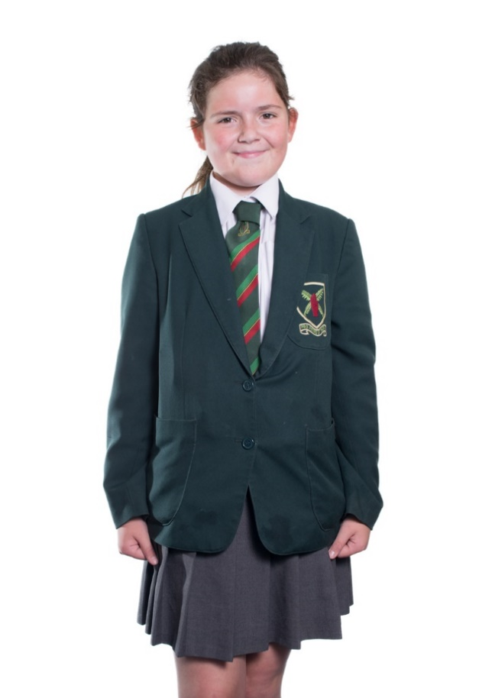

**Boys**

• *Boys should not wear their hair excessively long or short.

• Hair length must not be less than a No 3 cut.

• Longer hair must not be past the shirt collar or obscure the face.

• Extreme styles are not allowed.

• Hair of different lengths must be blended and lines or patterns are not allowed.

• Hair gel / wax must not be worn.

• Hair must be one natural colour.

• Boys must be clean shaven

**Uniform**

• Green Blazer with school badge.

• Pullover (if worn) v neck, plain green (Not to be worn instead of a blazer)

• Plain white shirt: worn correctly (tucked into trousers) top button must be fastened.

• Tie: worn to correct length, crest visible below tied knot.

• Trousers: plain black-no fashion/jeans style.

• Socks: plain black

• Shoes: plain black. Boots, trainers or pumps are not allowed. Sports branded footwear (such as ‘Nike’) is not allowed.

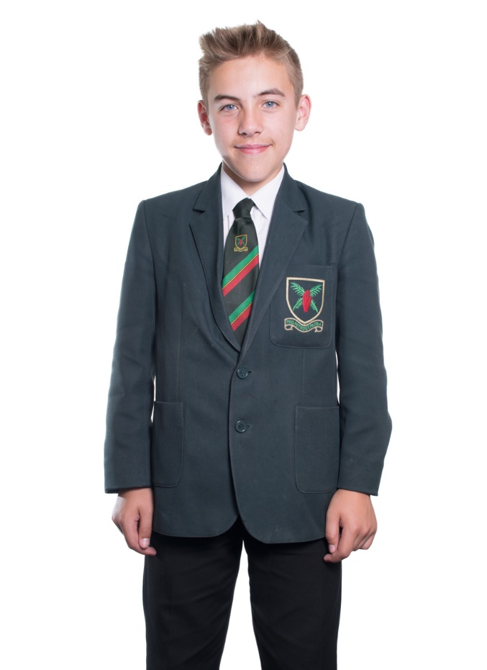

**For Physical Education**

All items of kit must be named. Your child’s initials or first name must be embroidered/sewn/or printed on the right hand side of their polo-shirt and shorts.

**Girls' Kit**

• Black shorts/skorts with school motif (indoor and outdoor use).

• White polo-shirt with school motif (indoor and outdoor use).

• Plain black football socks (outdoor use).

• Plain black ankle socks (indoor use).

• Trainers suitable for use on Astro-turf.

• Shin pads.

• Towel.

**Recommended**

• Gum Shield

• Scrum cap, shoulder pads (Rugby)

• Red hoodie with school motif

• Black joggers with school motif

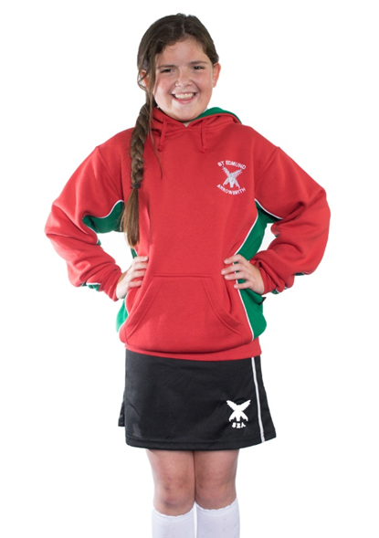

**Boys’ Kit**

* Black shorts with school motif (indoor and outdoor use).
* White polo-shirt with school motif (indoor and outdoor use).
* 2 pair of black football socks (1 for indoor use and 1 for outdoor use).
* Football boots.
* Trainers suitable for use on Astro-turf.
* Towel.

**Recommended**

* Gum Shield
* Scrum cap, shoulder pads (Rugby)
* Red hoodie with school motif
* Black joggers with school motif
* Shin pads – for football

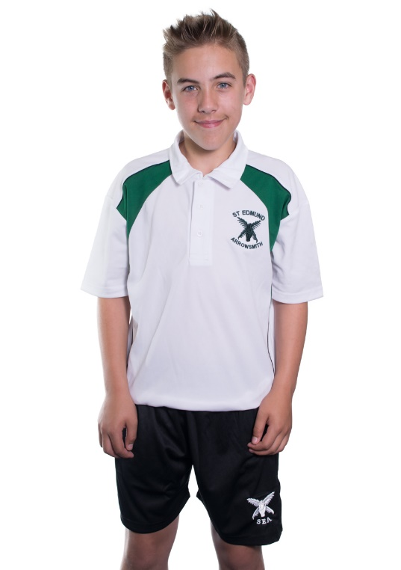

**\*Disclaimer: The school reserves the right to make the final judgement on any of the above**

**ORDER AND DISCIPLINE**

In order that our community functions effectively and happily expectations of pupils are high. Consideration for others is stressed, as is the importance of each pupil fulfilling her/his potential. Pupils are encouraged to take pride in every aspect of their school lives; work, appearance, relationships and care of the fabric of the buildings are examples of where this principle applies. The expectations we have of our pupils is laid out in the “Code of Conduct”. This can be found in the Pupil Planner which all pupils receive.

It is believed that teachers and pupils should be dealing with rewards more frequently than dealing with punishments, and that discipline should be dealt with positively via approval and recognition of success.

When, however, it is felt necessary, sanctions are imposed. A range of sanctions is used, each case being separately assessed. Sanctions, in school, are regularly reviewed. These have been agreed and form part of the Whole School Behaviour Policy, which can be found on the school’s website – [www.arrowsmith.wigan.sch.uk](http://www.arrowsmith.wigan.sch.uk). Sanctions may include:

1. imposition of extra work;
2. detention at break time/lunch time or after school (24 hours notice is always given for after school detentions);
3. withdrawal of privileges;
4. a pupil working in isolation for a period of time.

If a child is causing serious concern at school, either because of poor work or behaviour, parents will be notified by the Senior Learning Coordinator. Should the problems persist the parents will be asked to come to school to discuss the matter. Following serious incidents, a pupil may be excluded from school for a set period, and ultimately the exclusion may be permanent.

Every effort is made to maintain good working relationships and foster the home/school partnership. Parental support is sought constantly to attain the high standards expected of our young people. This can best be achieved when we work together.

**RATIONALE UNDERPINNING SCHOOL BEHAVIOUR POLICY**

The policy rests firmly on pupil choice and pupils taking responsibility for their own actions.

If a pupil chooses to disrupt a lesson or misbehave in a classroom or on the school premises, we believe it is our duty to act. We feel it is grossly unfair for a pupil to disrupt the education of others, while at the same time harming their own life chances.

Teachers will deal with disruption in a way that is appropriate and in proportion to the offence. I am sure all parents would expect this to happen and support the action taken. If, however, the frequency or level of disruption/misbehaviour increases and the pupil continues to confront our set rules and procedures, the situation will become more grave and will escalate. The young person has chosen to be uncooperative and, must, therefore, answer for the consequences of her/his actions. All pupils are made fully aware of the nature of the sanctions which can be applied. It is their choice to persist with behaviour which will merit a pre-ordained punishment. Parents will always be informed of any concerns we have in our dealings with their children.

We are not perfect and will, occasionally, make mistakes. I can assure you however, that we always act in the best interests of your child and do our utmost to be fair and consistent in our dealings with both pupils and parents. Children may come home with a “version” of events. I would request that any concerns you have be communicated to us and we can work together to resolve most issues. You, as parents, may not always agree with our action but I would ask for your support as we strive to do our very best for your child.

School Policy re Mobile Phones

* The school would prefer pupils not to bring mobile phones to school. This is for reasons of security. If a pupil does bring a mobile into school, it is their responsibility, not the responsibility of the school.
* Pupils must not use their phone anywhere on the school site during the school day. This includes making or receiving calls, texts, emails, taking photographs, listening to music. In essence, phones should not be seen and always be turned off when pupils are on site.
* Pupils found using their mobile phones, in any capacity*, will have their phone taken off them by a member of staff. This will be kept securely in the school office until a parent/guardian can collect it. If this is not possible it will be retained for 1 week and then returned to the pupil.

The school accepts that mobile phones are “part and parcel” of everyday life for many young people. However, the nonessential use of mobile phones on the school site and related issues are a distraction to our core purpose; providing a sound education for our young people.

In the event of an emergency, pupils can speak directly to a senior member of staff to resolve their problem.

*There are occasions when pupils are directed to use their phones during lessons by the classroom teacher to enhance the learning or conduct some research. All pupils connect to the school Wi-Fi and must abide by the acceptable use policy included in our Whole School IT Security Policy and BYOD (Bring your own device) Policy. Pupils must be supervised when using their phones otherwise they risk it being confiscated.

CODE OF CONDUCT

As members of our school community we aim to show **RESPECT** at all times.

* For oneself : Pride in yourself

: Punctuality

: Tidiness in uniform and work

: Truthfulness

* For others : Respond respectfully to requests

: Listen to others

: Show sympathy and tolerance

: Use appropriate language and manners

(address teachers as Sir or Miss)

: Move quietly and sensibly around the school

* For property : Take care of school property

: Keep the school clean and tidy

: Don't drop litter or chew gum

# SHOW RESPECT AT ALL TIMES

**ATTENDANCE**

It is the legal responsibility of parents/guardians to ensure that their children attend school regularly and punctually. Any absence from school must, by law, be accounted for and the number of authorised and unauthorised absences must now be published each year in the school prospectus.

Attendance is recorded twice daily and absences are recorded as either “authorised” or “unauthorised”. Persistent, avoidable lateness may also constitute “unauthorised absence”. Only the school may authorise an absence. A register is also taken at the beginning of all lessons.

When a child is absent from school, it is expected that the school will be informed on the first day of absence by telephone or email. An explanatory letter, covering each and every absence is required later so that an accurate record may be kept; your child’s Pupil Planner may be used for this purpose. We are currently using a communication system which contacts parents by text, voicemail or email when their child is absent and no message has been left. You should respond by text or telephone.

Do you have a smartphone? Why not download our new app? This will be an additional way to inform us of your child’s absence and receive notifications. See the separate leaflet for details.

**Parents are asked to ensure, wherever possible, that family holidays are not taken in term time. This can cause severe disruption to your child’s education and can result in vital assessment opportunities being missed. Holidays taken during school time will usually be classed as unauthorised absence, unless exceptional circumstances prevail. Headteachers no longer have the authority to authorise family holidays.**

In order to minimise disruption to their child’s education, parents are asked to arrange medical appointments outside school hours. If this is not possible, written notes are required for permission to leave school when a pass will be issued. These passes are available from Mrs Pritchard in the Pastoral Office at morning registration on the day in question. This pass must be shown at Reception just before leaving school where they must also sign out.

We expect all pupils to aim for 100% attendance and must arrive punctually each day in order for them to benefit fully from the education and opportunities offered at St Edmund Arrowsmith Catholic High school.

**Attendance Facts**



**90% and below Serious cause for concern.**

**91% - 93% Poor**

**94% - 95% Below Average**

**96% Average**

**97% - 98% Good**

**99% Very good**

**100% Excellent**

**ATTENDANCE MATTERS!**

**Good attendance is essential if you are to achieve your potential in school.**

**With 100% attendance, you will be able to make the best of all the opportunities available to you.**

**Pupils with good attendance are more likely to achieve an increased number of higher grade GCSEs or equivalent qualifications.**

**Poor attendance will have a serious impact on your education, work ethic and life opportunities in the future.**

../../../../../Library/Containers/com.apple.mail/Data/Library/Mail%20Downloads/27FD4626-9884-45C9-BD04-6A4C53A64391/3.My%20Ed%20-%20Large%20Flyer.

**TRANSPORT**

A high proportion of our pupils have to travel by bus to school. School bus services are organized by Transport For Greater Manchester. School has no authority over the services provided and we work in partnership with the bus companies to ensure the safety and well-being of pupils using these services. For routes not designated a “school service”, pupils must use normal service buses and you will need to check times and available routes with the individual bus companies concerned.

To assist with the monitoring of behaviour on the school service buses we appoint Y11 Bus Prefects. They also support Y7 pupils in settling in and getting used to travelling to school each day on the bus.

We have implemented a School Bus Code of Conduct for pupils reminding them of the expectations and consequences of poor behaviour on the bus. Please see below:

**SCHOOL BUS SERVICES CODE OF CONDUCT**

• All pupils are expected to conduct themselves on the buses like they would in school.

• The safety of pupils, bus drivers and other road users can be affected by poor behaviour on the bus.

• Please follow all instructions issued by the Bus Prefects eg fasten seatbelts, no standing or distracting the driver, throwing items, bullying, leaving rubbish etc.

• The school will not tolerate poor behaviour on the buses. This is not fair to your fellow passengers or to the bus companies that provide the bus service.

• Your behaviour is a reflection of St Edmund Arrowsmith Catholic High School, and we pride ourselves on our reputation

If behaviour causes concern this is the procedure and consequence if it does not improve:

Stage 1: The bus prefect will politely ask you to refrain from causing a disruption. If no notice is taken and the poor behaviour continues they will report the matter to Mrs Chapman.

Stage 2: Mrs Chapman will notify the appropriate SLC who will speak to you directly.

Stage 3: If there is no improvement, a warning letter will be sent home advising parents of the unacceptable behaviour setting out a time frame for improvement.

Stage 4: After the agreed time frame, if there is no improvement, a further letter will be sent home implementing a temporary ban, possibly 2 weeks or half a term depending on the severity of the behaviour.

Stage 5: On return, any further incident will result in an immediate permanent ban.

I agree to the above code of conduct and acknowledge there will be consequences if my behaviour falls below the expected standard.

Pupils will be asked to sign a copy of the code of conduct and we would appreciate if you could acknowledge and support the school with it’s implementation. See enclosed form.

It is essential all pupils apply for an Igo pass to receive concessionary fares.

The Igo form is available from TGFM Travel Shops. This can be stamped in school during the induction days if required.

For local bus and train information please telephone

0871 200 2233 or visit <https://www.tfgm.com/>

Applications for a Yellow School Bus pass should have been completed by 30th June 2018, however you can still apply using the following link. Places are not guaranteed. Please log onto the following webpage: <https://tfgm.com/tickets-and-passes/bus-yellow-school-buses>

For details of saver tickets and network routes available: <http://www.systemonetravelcards.co.uk/>

System One Weekly Saver ticket start from £9.95 and a 28 Day Saver ticket start from £35.75

Here’s a list of local bus companies who accept System One:- Including Yellow Bus operators

* Arriva
* Cumfy Bus
* Diamond Bus North West *
* Finches of Wigan
* First Manchester
* Jim Stones
* M Travel
* Springfield Bus and Coach
* Stagecoach (Manchester, Wigan, Merseyside and South Lancashire)
* UK Coachways
* Wigan Buses

Pupils in receipt of Free School Meals will continue to be entitled to free bus travel but should contact the council for an application form or to check eligibility.

Wigan Council – Tel Number: 01942 489685

<https://www.wigan.gov.uk/Resident/Education/Home-to-school-travel/Home-to-school-travel.aspx>

St Helens Council – Transport Section 01744 671033

[www.sthelens.gov.uk/schools-education/school-college-transport/transport-assistance-for-secondary-aged-pupils/](http://www.sthelens.gov.uk/schools-education/school-college-transport/transport-assistance-for-secondary-aged-pupils/)

At this moment in time, tenders are being negotiated for school transport 2018-2019. It is, therefore, inappropriate to give exact details of the arrangements; these will be given to you as soon as they become available.

A timetable is included in your pack, however please remember these are for the current academic year only. Times and services are reviewed on an annual basis and changes may have occurred. It is essential that you check the school website during the summer holidays for updated details or refer to the TfGM website.

|  |  |  |  |  |
| --- | --- | --- | --- | --- |
|  | Service No | Operator |  | Costs (subject to change) |
| Children living in the Hindley/Hindley Green area | Y66/Y67/  Y64 | Stagecoach in  Wigan * | Hindley Green/Hindley/Platt Bridge/Bamfurlong/Ashton | £2.00 Wigan concessionary dayrider  £7.50Weekly Wigan Easyrider |
| Y65 | Stagecoach in Wigan * | Weekly ticket £7.00 valid on Yellow Bus service only |
| 920 | Stagecoach in  Wigan * | 4.15pm bus for pupils holding a Yellow Bus Pass |  |
| Children living in Platt Bridge area | 620/320 | Wigan Buses Ltd / Arriva Merseyside | Public Service Bus - Lower Ince/Platt Bridge/Bamfurlong/Ashton | Daysaver/Weekly &  4 Weekly ticket –see Arriva website |
| Children living in the Ince/Hindley/Platt Bridge area | 920 | Stagecoach in Wigan (PM) | Ince Bar/Hindley Bird in th’ Hand/Platt Bridge/Bamfurlong/Ashton |  |
| Children living in the Abram/Platt Bridge area | Y26 | Stagecoach * | Abram (Dover Lock)/Platt Bridge/ Bamfurlong/ Ashton | Weekly ticket £7.00 valid on Yellow Bus service only |
| Children living in Garswood | 156  652 | Arriva Merseyside  Red Kite Travel | St Helens/Garswood/Bryn cross/Ashton  Garswood/Bryn Cross/Ashton |  |
| Children living in Haydock/St Helens area | 320 | Arriva Merseyside | Service Bus from Ashton/St Helens | Daysaver/Weekly &  4 Weekly ticket –see Arriva website |
| Children living in Winstanley area | 604/603 | Diamond Bus NW | Windy Arbour/Worsley Mesnes/Highfield Grange/Hawkley Hall | £7.00 Weekly ticket |
| 603/604 | Pemberton Rail Station/Holmes House Avenue/Marus Bridge |
| Children living in Golborne/Lowton area | 600 | Stagecoach in Wigan | Service Bus | £2.00 Wigan concessionary dayrider  £7.50 Weekly Wigan Easyrider |
| Children living in Newton Le Willows area | 654 | Halton Borough Transport | (AM only) Newton Hospital/Penny Lane, Haydock/School | £1per journey – No weekly ticket available |
| 603  655 | Huyton Travel Ltd  Red Kite travel | Service Bus – pm  This service has a capacity of only 33  (PM only) A trial service has been successful and will continue to operate for 18/19 | £1 per journey – No weekly ticket available  £1 per journey |

Yellow Bus Services *

**CASHLESS CATERING SYSTEM**

We use a voluntary biometric recognition system in order to administer the cashless catering system in both of our school dining rooms. This system provides us with some significant benefits including:

* Reduction in pupil queuing time
* Reduction in need for cash handling
* No problems created by lost cards
* Reduced opportunities for theft or bullying

More information regarding our use of the system and the data it generates can be found below.

In order to comply with the provisions of the Protection of Freedoms Act 2012 we now need written permission from a parent in order to allow pupils to use the biometric system. This consent can be withdrawn at any time in writing.

**USE OF BIOMETRICS**

**Background:**

We have used the biometric system to administer our cashless catering system since its installation in June 2011.  Biometric information is information about someone’s physical or behavioural characteristics that can be used to identify them.  There are many possible biometrics, including digital photographs, fingerprints or hand shapes.  As part of our identity management system we record a biometric measurement taken from a finger, but not a fingerprint image.  The data, which is held as a short numeric code, is sufficient to recognise someone in a school community; but the amount of data held cannot be used to uniquely identify someone from a much larger population. The data cannot be accessed on any computer other than the school’s licenced server.  The information is stored in a highly secure database and is only used by the school.

The data that is held cannot be used to recreate a fingerprint image and will not be used by any other agency for any other purpose.

The school will not use the biometric information for any purpose other than that stated above.  The school will store the biometric information collected securely in compliance with the Data Protection Act 1998.  The school will not share this information with anyone else and will not unlawfully disclose it to any other person.

**The Protection of Freedoms Act, 2012:**

This legislation requires schools to –

* Inform parents about the use of biometrics in the school and explain what applications use biometrics.
* Receive written permission from one parent if the school is to continue processing biometrics for their child.
* Allow children to choose an alternative way of being identified if they wish.

Children who do not have this parental permission by 04 September 2018 will not be able to use the biometric service in school.

 If you do not wish your child to use the biometric system we will provide an alternative form of identification in the form of a Card.  The initial Card will be free but any replacement will cost £3.00.

Please note that when your child leaves school her/his biometric data will be permanently deleted.

If you require more information about the biometric system please do not hesitate to contact the school.

**WISEPAY ONLINE PAYMENT SERVICE**

The school uses an online payment system, Wisepay.  This enables you to load payments onto the cashless catering system for purchasing school meals.  The minimum value is £15; this represents 5 days @ £3 per day.  Any amount above this can be loaded if you wish to pay monthly or termly.  The maximum spend per pupil is £5 per day, however this can be set on an individual basis if you wish your child to have less/more per day.  Please send this request in writing For the Attention of Tina Snowden, Catering Manager for Catering Academy Ltd.  Cheques will continue to be taken as normal using the post box in school.  They should be deposited no later than 10am to ensure the money is in their account by break time.  Cash can still be loaded using the revaluation unit in the dining room, however NO requests for change will be accepted from pupils.  It will be imperative that you send your child with the correct amount you wish them to load for school meals.

The online payment service also includes payments for many trips.  As school is absorbing the transaction charges made by the card companies we will be keeping this method of payment to a minimum value of £10.  Therefore, certain events, trips, purchases etc. will continue to be paid for using the traditional methods of cash or cheques.

**How will I access WisePay?**

To avoid the need for additional usernames and passwords you will access Wisepay through the Parent Portal on the school website.  The Parent Portal allows you to access information relating to your child’s progress and attendance in school.  Please note that only the parent identified as priority 1 on our SIMS system will have access to the WisePay button on the Parent Portal.

**Who are WisePay?**

WisePay is a secure online payment company that allows parents and guardians to make payments to their school using their debit or credit cards.  The WisePay service operates in many schools, local authorities, academies and colleges across the UK and has been established for over 20 years.

**What are the advantages of using WisePay?**

Using your debit or credit card, payments to your school can be made conveniently from home, office or anywhere that has an internet connection.

Payments can be made 24/7.  You do not have to wait until your school is open and you do not have to write cheques or find cash.  Furthermore, at any time you can see your payment history in your “Wise Account”.  Additionally, you can track every transaction that you make.

**What happens to my money?**

All money that you pay goes directly and immediately to either your school’s bank account or the catering provider’s bank account.  WisePay does not take or hold any of your money at all.

**Is WisePay easy to use?**

WisePay is extremely easy to use.  Its visual and simple instructions are very quick and easy to follow, even for anyone who has never made an online payment or purchase before.

**How long do the payments take to reach my school?**

All online payments are made in real time, so the payment will be credited to your account instantly.  However, there may be a delay depending on the timings of when the systems “sync”.  Any payments made before 10am will be visible to the pupil no later than the start of break.

**What credit or debit cards can I use?**

Payments to your school through WisePay can be made with all well known credit or debit cards.

**Is my payment and the payment site secure?**

Yes.  All pages viewed on WisePay are encrypted using a Secure Socket Layer (SSL) session.

**Who can see my card details?**

Neither WisePay nor the school can see, or has access to, any of your card details.  Your card details are never stored by WisePay.

**How does my school know I have paid?**

The Catering Manager (for school meals) and the Finance Department (trips, etc.) are notified that you have made a payment.  They know which student the payment is for, how much has been paid and the item that you have paid for.

**Will I get a receipt for my payment?**

Yes, you will automatically receive a receipt directly to your email address for every payment that you make.

**How do I view my transactions?**

Once logged in to your account, you can access your “Wise Account”.  Just click on the “Wise Account” tab on the top right of the screen.

From here you can see all your transaction history, view dinner money balances and change some of your account details, such as email address or telephone number.

**Merged Accounts**

Sibling accounts have been merged, this will enable funds to be added whilst logging into WisePay once.  If this is not required or there are additional pupils to be merged please contact the school with the information.

If you experience any difficult accessing the Parent Portal or the WisePay online system please do not hesitate to contact the school.

We are anticipating that all new parents will have full access to the system by Friday 31st August 2018 in preparation for your child’s first day in school, subject to you providing relevant details which must include an email address.

**FREE SCHOOL MEALS AND PUPIL PREMIUM**

**Does your child qualify for Free School Meals?**

**Do you work in the armed services?**

**Has your child been adopted?**

* If they were looked after by an English or Welsh local authority immediately before being adopted, or who left local authority care on a special guardianship order or child arrangements order (previously known as a residence order).

**Does the school know? If not please tell us** **by completing the Pupil Detail Form.**

The Government provides funding to school to support these pupils and is called “Pupil Premium’.

**For every child registered, St Edmund Arrowsmith Catholic High School gets between £300 and £2300.**

The Funding is used by the school for various strategies including employing additional learning support staff, providing extra revision classes, homework and reading clubs and specialist one-to-one tuition for identified pupil premium children, where appropriate.  For full details please refer to our Pupil Premium statement on the website in the policies and procedures section.

Not sure if you may qualify for Free School Meals? Wigan Council have introduced a new service that enables school to check if you are eligible for FSM without having to complete a long application form. All you need to provide us with is your NI number on the enclosed form (See enclosed form).  We can claim even if your child does not want to take their entitlement!

**Laptops for Pupils**

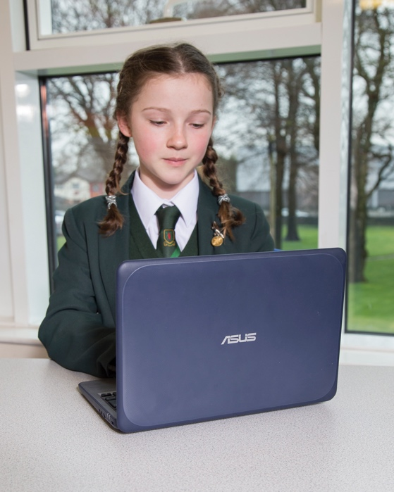We will be launching Laptops for Pupils in Autumn 2018!

Due to the rising demand for IT in school, and the substantially reduced school budget, we are exploring different avenues to allow IT to continue in school.

Our aim is to provide your child with access to all school resources both in and out of school, with the reassurance that theft and accidental damage is covered. We can achieve this at a price cheaper than the shops, including warranties and insurance. It will allow pupils to access a range of applications and software, such as Adobe Photoshop, Python, 2d design, without the need for parents to purchase the software themselves.

Work can be submitted digitally using the device at any time of the day, giving teachers more efficient ways to provide feedback. Using digital ink or recorded messages, it removes the need to print work, saving both parents and school significant sums of money which can be better spent elsewhere.

Our aim is to provide a device, where teachers and pupils can collaborate together, working on the same documents simultaneously, without the worry of the device running low on battery. It needs to be light, portable and usable in all parts of school life. We feel that we have found a device which meets all of these needs.

**Key Benefits**

* Children are safe guarded at home and in school
* Internet filtering is applied at all times even over your own internet
* Screen shots are taken and monitored to ensure that your child is safe online and in class
* School provides all the software needed in class at no extra charge, saving thousands of pounds in purchases
* Personalised device to optimise learning
* Long battery life
* Three-year warranty including accidental damage
* Essential access to IT 24/7
* Durable laptop designed for education which is also splash proof

Your child’s device will be covered for 3 years, including accidental damage. Please note loss is not covered under the insurance and there is a claims limit per student.

Visit our website for more information: [www.arrowsmith.wigan.sch.uk/year-7-laptops-for-pupils](http://www.arrowsmith.wigan.sch.uk/year-7-laptops-for-pupils)

**IMAGES/PHOTOGRAPHS/PUBLICATIONS**

You may be aware, the General Data Protection Regulation came into force from the 25th May 2018. This has placed additional obligations on organisations which will affect how they handle data.

We take cyber security and data protection very seriously and we have put steps in place within our organisation to ensure we maintain secure and compliant systems. As part of this obligation we have reviewed our consents to photographic images.

As a school, we regularly use photographs to show how our pupils and the school as a whole develop. Images can also help us illustrate and communicate with parents about upcoming events and can help advertise and market the school to prospective parents and pupils.

We are also aware that parents and pupils really enjoy being able to see their images and would like to give all pupils this opportunity.

There are a number of instances when the school may take photos of your child, specifically: -

* We publish photos on the school’s website to promote the school to current and prospective parents as well as providing updates on current events;
* We publish photos on our social media accounts such as Twitter to provide updates on events and news within the school. The school ensure that its privacy settings are such to limit viewing of photos to followers of the school accounts (as approved by the school);
* From time to time we put videos on our you tube channels which can be seen by subscribers to our channel;
* Within our newsletters, we may provide photos of recent events or achievements from our pupils;
* In order to promote the school, we send out prospectuses, flyers, leaflets and brochures which contain images to show life at our school. These will be sent to prospective parents;
* We may also use other promotional materials such as banners and signs which may contain photographic images for prospective parents to view;
* We may be visited by the media who will take photographs or film footage of events. Pupils will sometimes appear in these images, which may then be published in local or national newspapers, in televised news programmes and on social media sites;
* We publish photos in and around the school building to illustrate to current pupils and parents life around the school including educational materials and images of recent trips and events. These can be seen from time to time by other parents or visitors within the school;
* In promotional materials to show the history and character of the school to future generations.

We follow guidance as set by data protection legislation (mainly the General Data Protection Regulation) as well as guidance set by the Information Commissioner’s Office on taking photos in schools and obtaining consent.

The data protection laws give children rights over their own data where they are considered to have the required capacity to understand their data rights. Most children will reach this level of understanding from the age of 12 and so it may be necessary for the school to obtain this consent from the child directly. The school has deemed the end of KS3 (Year 9) as appropriate and all pupils will update their preferences at this point in consultation with their parent/carer. (At the Pupil Review Day)

If this is not suitable, the school will consider preferences set out below.

Usually pupils will not be named in the photographs unless they gain specific consent in the first instance.

Consent to using your child’s images will last throughout your child’s time at the school and will continue to apply for a short time after they leave (except for images published for historical purposes which may be kept for an extended period of time to show the history of the school).

We would like to seek your consent to the use of your child’s images and will respect your decisions when publishing photos moving forward.

You can withdraw your consent at any time and can do so by writing to the school asking them to stop using your child’s images. At that point they will not be used in future publications but we cannot prevent them from continuing to appear in publications already in circulation.

**Privacy Notice for St Edmund Arrowsmith Catholic High School**

St Edmund Arrowsmith Catholic High School is committed to protecting the privacy and security of personal information. This privacy notice describes how we collect and use personal information about pupils, in accordance with the General Data Protection Regulation (GDPR), section 537A of the Education Act 1996 and section 83 of the Children Act 1989.

**Who Collects This Information**

St Edmund Arrowsmith Catholic High School is a “data controller.” This means that we are responsible for deciding how we hold and use personal information about pupils.

**The Categories of Pupil Information That We Collect, Process, Hold and Share**

We may collect, store and use the following categories of personal information about you: -

* Personal information such as name, pupil number, date of birth, gender and contact information;
* Emergency contact and family lifestyle information such as names, relationship, phone numbers and email addresses;
* Characteristics (such as ethnicity, language, nationality, country of birth and free school meal eligibility);
* Attendance details (such as sessions attended, number of absences and reasons for absence);
* Financial details;
* Post 16 learning information;
* Performance and assessment information;
* Behavioural information (including exclusions);
* Special educational needs information;
* Relevant medical information;
* Special categories of personal data (including biometric data, ethnicity, relevant medical information, special educational needs information;
* Images of pupils engaging in school activities, and images captured by the School’s CCTV system;
* Information about the use of our IT, communications and other systems, and other monitoring information;

**Collecting This Information**

Whilst the majority of information you provide to us is mandatory, some of it is provided to us on a voluntary basis. In order to comply with the General Data Protection Regulation, we will inform you whether you are required to provide certain pupil information to us or if you have a choice in this.

It is important that the personal information we hold about you is accurate and current. Please keep us informed if your personal information changes during your working relationship with us.

**How We Use Your Personal Information**

We hold pupil data and use it for: -

* Pupil selection (and to confirm the identity of prospective pupils and their parents);
* Providing education services and extra-curricular activities to pupils, and monitoring pupils' progress and educational needs;
* Informing decisions such as the funding of schools;
* Assessing performance and to set targets for schools;
* Safeguarding pupils' welfare and providing appropriate pastoral (and where necessary medical) care;
* Support teaching and learning;
* Giving and receiving information and references about past, current and prospective pupils, and to provide references to potential employers of past pupils;
* Managing internal policy and procedure;
* Enabling pupils to take part in assessments, to publish the results of examinations and to record pupil achievements;
* To carry out statistical analysis for diversity purposes;
* Legal and regulatory purposes (for example child protection, diversity monitoring and health and safety) and to comply with legal obligations and duties of care;
* Enabling relevant authorities to monitor the school's performance and to intervene or assist with incidents as appropriate;
* Monitoring use of the school's IT and communications systems in accordance with the school's IT security policy;
* Making use of photographic images of pupils in school publications, on the school website and on social media channels;
* Security purposes, including CCTV;
* Where otherwise reasonably necessary for the school's purposes, including to obtain appropriate professional advice and insurance for the school;
* To provide support to pupils after they leave the school;

**The Lawful Basis on Which We Use This Information**

We will only use your information when the law allows us to. Most commonly, we will use your information in the following circumstances: -

* Consent: the individual has given clear consent to process their personal data for a specific purpose;
* Contract: the processing is necessary for a contract with the individual;
* Legal obligation: the processing is necessary to comply with the law (not including contractual obligations);
* Vital interests: the processing is necessary to protect someone’s life.
* Public task: the processing is necessary to perform a task in the public interest or for official functions, and the task or function has a clear basis in law; and
* The Education Act 1996: for Departmental Censuses 3 times a year. More information can be found at: <https://www.gov.uk/education/data-collection-and-censuses-for-schools>.

We need all the categories of information in the list above primarily to allow us to comply with legal obligations. Please note that we may process information without knowledge or consent, where this is required or permitted by law.

**Sharing Data**

We may need to share your data with third parties where it is necessary. There are strict controls on who can see your information. We will not share your data if you have advised us that you do not want it shared unless it’s the only way we can make sure you stay safe and healthy or we are legally required to do so.

We share pupil information with: -

* the Department for Education (DfE) - on a statutory basis under section 3 of The Education (Information About Individual Pupils) (England) Regulations 2013;
* Ofsted;
* Youth support services – under section 507B of the Education Act 1996, to enable them to provide information regarding training and careers as part of the education or training of 13-19 year olds;
* Other Schools that pupils have attended/will attend;
* NHS;
* Welfare services (such as social services);
* Law enforcement officials such as police, HMRC;
* Local Authority Designated Officer;
* Professional advisors such as lawyers and consultants;
* Support services (including insurance, IT support, information security);
* The Local Authority.
* GDPR Compliant third party service providers.

Information will be provided to those agencies securely or anonymised where possible.

The recipient of the information will be bound by confidentiality obligations, we require them to respect the security of your data and to treat it in accordance with the law.

**Why We Share This Information**

We do not share information about our pupils with anyone without consent unless otherwise required by law.

For example, we share student’s data with the DfE on a statutory basis which underpins school funding and educational attainment. To find out more about the data collection requirements placed on us by the DfE please go to https://www.gov.uk/education/data-collection-and-censuses-for-schools.

**Storing Pupil Data**

The School keeps information about pupils on computer systems and sometimes on paper.

Except as required by law, the School only retains information about pupils for as long as necessary in accordance with timeframes imposed by law and our internal policy.

If you require further information about our retention periods, please let Mrs Suzanne Chapman, School Business Manager, know who can provide you with a copy of our policy. This policy can be found on the school website: www.arrowsmith.wigan.sch.uk/ourschool/policiesandprocedures

**Automated Decision Making**

Automated decision making takes place when an electronic system uses personal information to make a decision without human intervention. We are allowed to use automated decision making in limited circumstances.

Pupils will not be subject to automated decision-making, unless we have a lawful basis for doing so and we have notified you.

**Security**

We have put in place measures to protect the security of your information (i.e. against it being accidentally lost, used or accessed in an unauthorised way).

**Youth support services**

**Pupils aged 13+**

Once our pupils reach the age of 13, we also pass pupil information to our local authority and / or provider of youth support services as they have responsibilities in relation to the education or training of 13-19 year olds under section 507B of the Education Act 1996.

We must provide the pupils name, the parents name(s) and any further information relevant to the support services role.

This enables them to provide services as follows:

* youth support services
* careers advisers

A parent or guardian can request that only their child’s name, address and date of birth is passed to their local authority or provider of youth support services by informing us. This right is transferred to the child / pupil once he/she reaches the age 16.

**Pupils aged 16+**

We will also share certain information about pupils aged 16+ with our local authority and / or provider of youth support services as they have responsibilities in relation to the education or training of 13-19 year olds under section 507B of the Education Act 1996.

This enables them to provide services as follows:

* post-16 education and training providers
* youth support services
* careers advisers

For more information about services for young people, please visit our local authority website. [www.wigan.gov.uk](http://www.wigan.gov.uk)

**The National Pupil Database**

The NPD is owned and managed by the Department for Education and contains information about pupils in schools in England. It provides invaluable evidence on educational performance to inform independent research, as well as studies commissioned by the Department. It is held in electronic format for statistical purposes. This information is securely collected from a range of sources including schools, local authorities and awarding bodies.

We are required by law, to provide information about our pupils to the DfE as part of statutory data collections such as the school census and early years’ census. Some of this information is then stored in the NPD. The law that allows this is the Education (Information About Individual Pupils) (England) Regulations 2013.

To find out more about the NPD, go to <https://www.gov.uk/government/publications/national-pupil-database-user-guide-and-supporting-information>.

The department may share information about our pupils from the NPD with third parties who promote the education or well-being of children in England by:

* conducting research or analysis
* producing statistics
* providing information, advice or guidance

The Department has robust processes in place to ensure the confidentiality of our data is maintained and there are stringent controls in place regarding access and use of the data. Decisions on whether DfE releases data to third parties are subject to a strict approval process and based on a detailed assessment of:

* who is requesting the data
* the purpose for which it is required
* the level and sensitivity of data requested: and
* the arrangements in place to store and handle the data

To be granted access to pupil information, organisations must comply with strict terms and conditions covering the confidentiality and handling of the data, security arrangements and retention and use of the data.

For more information about the department’s data sharing process, please visit: <https://www.gov.uk/data-protection-how-we-collect-and-share-research-data>

For information about which organisations the department has provided pupil information, (and for which project), please visit the following website: <https://www.gov.uk/government/publications/national-pupil-database-requests-received>

To contact DfE: <https://www.gov.uk/contact-dfe>

**Requesting Access to Your Personal Data**

Under data protection legislation, parents and pupils have the right to request access to information about them that we hold. To make a request for your personal information, or be given access to your child’s education record, contact Mrs S Chapman, School Business Manager.

You also have the right to: -

* Object to processing of personal data that is likely to cause, or is causing, damage or distress;
* Prevent processing for the purposes of direct marketing;
* Object to decisions being taken by automated means;
* In certain circumstances, have inaccurate personal data rectified, blocked, erased or destroyed; and
* Claim compensation for damages caused by a breach of the data protection regulations.

If you want to exercise any of the above rights, please contact Mrs S Chapman, School Business Manager, in writing.

We may need to request specific information from you to help us confirm your identity and ensure your right to access the information (or to exercise any of your other rights). This is another appropriate security measure to ensure that personal information is not disclosed to any person who has no right to receive it.

**Right to Withdraw Consent**

In circumstances where you may have provided your consent to the collection, processing and transfer of your personal information for a specific purpose, you have the right to withdraw your consent for that specific processing at any time. To withdraw your consent, please contact the school office. Once we have received notification that you have withdrawn your consent, we will no longer process your information for the purpose or purposes you originally agreed to, unless we have another legitimate basis for doing so in law.

**Contact**

If you would like to discuss anything within this privacy notice or have a concern about the way we are collecting or using your personal data, we request that you raise your concern with Mrs S Chapman, School Business Manager in the first instance.

We have appointed a data protection officer (DPO) to oversee compliance with data protection and this privacy notice. If you have any questions about how we handle your personal information which cannot be resolve by Mrs S Chapman, School Business Manager, then you can contact the DPO on the details below: -

Data Protection Officer Name: Craig Stilwell

Data Protection Officer Details: Judicium Consulting Ltd, 72 Cannon Street, London, EC4N 6AE

Data Protection Officer Email: [dataservices@judicium.com](mailto:dataservices@judicium.com)

You have the right to make a complaint at any time to the Information Commissioner’s Office, the UK supervisory authority for data protection issues at https://ico.org.uk/concerns.

**Changes to This Privacy Notice**

We reserve the right to update this privacy notice at any time, and we will provide you with a new privacy notice when we make any substantial updates. We may also notify you in other ways from time to time about the processing of your personal information.

**VOLUNTARY CONTRIBUTIONS**

**TECHNOLOGY**

In order to widen the choice, availability and quality of the materials and processes used by the pupils in Design & Technology and the ever increasing costs involved, it has become necessary to ask each pupil in years 7, 8 and 9 for a voluntary contribution of £3.00 towards the cost of the consumables involved. This donation will cover the costs for the whole of the academic year.

Some projects may include additional electronic components to become fully functioning products.  Where pupils wish to include these, additional charges will occur.  The inclusion of such components will not affect the progress or making of pupils’ work.

When pupils are undertaking their food preparation projects they are expected to provide the main ingredients themselves.  Where ingredients are provided by the department an additional cost will be required. All the additional money will be collected by the current teacher at the time of making and will be re-invested into the Technology department.

Your support towards the department is greatly appreciated, if you can include your donation in the envelope provided.

**BUILDING LEVY 2018/2019**

On behalf of the Archdiocese of Liverpool we are writing about the very important matter relating to the upkeep and future development of our Catholic schools. Unfortunately, unlike other categories of state schools, Catholic schools do not come free and 10% of any building and renovation costs have to be met by the Archdiocese. Therefore, the continued provision of Catholic education adds up to a huge sum- for example if a school has building work totalling £500,000 then the Archdiocese has to pay £50,000 of this total.

We have been fortunate to receive money from this fund over a number of years, and has been used to improve areas around school that have been identified as a priority by Governors.   In September 2015, we were awarded £350k to begin a major refurbishment project of the Science department.  This was only enough funding to provide three new laboratories and we looked to the Archdiocese to complete the project with additional funding. Last month we received notification of a further allocation of £335k to finish the refurbishment in the Science department! This will commence in the Spring Term of 2019!

To assist the Archdiocese, the school must make a contribution based on our number of pupils. This money is paid directly to the Archdiocese who prioritise work and oversee developments. We have benefitted significantly from this funding in recent years and is something we could not have achieved without the Archdiocese who use schools' levies to access Government Capital monies by being able to meet their 10% commitment.

The school has always paid this contribution on your behalf as we have prioritised this within our budget allocation.   Unfortunately we continue to see a reduction in funding from the Local Authority and are faced with a period of financial uncertainty as changes are implemented in educational funding.   Therefore, we feel we have no alternative to ask parents/carers to make a voluntary contribution towards the levy.

All Catholic schools in the Archdiocese ask parents to contribute towards this levy. The contribution requested is £10.00 per year per family attending school and with around 1,014 families attending the school our figure is £10,140.

This is a small price we are sure you will agree, to ensure that Catholic Education is maintained and developed and that St. Edmund Arrowsmith benefits from this support. We need your help in order to contribute our share as there is no provision within our school funding for such a levy- any shortfall in parental contributions will have to be taken from elsewhere within school funds.  The decision to request a contribution in the autumn term will allow any shortfall to be budgeted for in the new financial year when we make difficult decisions about what we have to do without.

We hope that we can rely on your support in helping our school to pay its contribution towards this vital annual appeal. The model of Catholic education is very clear in seeing the implicit link between home, school and parish. If St. Edmund Arrowsmith and other Catholic schools are to continue to have buildings fit for purpose then support from parents for a Catholic education for their children is crucial.

Please indicate on the Parental Consent Form if you are paying the levy, however there will be an option to pay online using WisePay from September 2018 when your child is admitted at St Edmund Arrowsmith Catholic High School.  If you have an older child in school this can be paid using their account. Please ensure you select 2018/2019 Levy. If you prefer to pay using this method please indicate.

**Fundraising and Marketing**

The school reformed its PTA in 2015 and regularly update parents on events and fundraising opportunities throughout the year. We welcome any new members and have a PTA page on the school website, www.arrowsmith.wigan.sch.uk/pta and Twitter account. @SEACHPTA.

The PTA have provided new library furniture, Football shirts and Spelling Bee prizes this year. Our goal is to improve the outdoor seating for pupils around school from the proceeds of the summer fair.

Regular fundraising takes place with our Christmas Raffle, Easter Raffle, 200 Club and annual Summer Fair.

Due to changes in Data Protection rules, we now have to ask parents to consent to receiving this type of information, including local community information that we sometimes send on an adhoc basic.

St Edmund Arrowsmith Catholic High School wish to seek your consent, as a parent/carer of a child attending the school, to be contacted by the School and/or other organisation such as fundraising organisation about:

* St Edmund Arrowsmith Catholic High School has a fundraising association who wish to communicate with parents about future events for the school. This is to promote the sense of community we have between the school and everyone associated with it, including parents, staff and pupils.
* St Edmund Arrowsmith Catholic High School will provide updates through its PTA as to upcoming events and meetings.
* St Edmund Arrowsmith Catholic High School will provide details about school clubs including information about local sports clubs.
* St Edmund Arrowsmith Catholic High School will provide details on uniforms and other marketing information such as information on local colleges.
* St Edmund Arrowsmith Catholic High School will provide useful medical information from the NHS in school (such as vaccination information and heights and weights).

We would like to seek your consent (as set out above) and will respect your decision moving forward.

By consenting to the School and/or other organisation contacting you, you are allowing us to provide your contact details to the association.

This consent will remain valid throughout your child’s time at the school.

You can withdraw your consent at any time and can do so by writing to the school asking them to stop sending further communications.

Please note that if you do not consent then you may not receive vital details from the School and/or the Fundraising Association about the information set out above. Please note that this does not cover providing you with information that we are legally entitled to notify you of, such as information concerning the progress of your child, closures of the school, etc.